 [Translated from German to English - www.onlinedoctranslator.com](https://www.onlinedoctranslator.com/en/?utm_source=onlinedoctranslator&utm_medium=docx&utm_campaign=attribution)

**1 Mechanics**

Pneumatic press technical documentation

**1.1 Functional description**

In the pneumatic press, workpieces can be processed with a force of approx. 220 N (at 4 bar).

After the workpieces are inserted, the workpiece holder transports the parts to be processed into the press chamber. The safety door then closes and the press cylinder begins to extend. After processing, the safety door opens and the workpieces are pushed out of the work chamber, ready for further transport.

The safety door ensures that the press has a completely enclosed working area during the pressing process, but the Plexiglas safety walls allow for observation of the pressing process. To further increase safety, a two-hand control is used for manual operation.

The functional assembly is mounted on 2 profile plates and can be installed together with other assemblies on an aluminum groove plate.

Two 8-bit transfer connectors are available as transfer modules for connection to six digital PLC inputs and eight digital PLC outputs.

The supply voltage of the functional module is 24 VDC and is provided via the 10-pin connecting cable.

The air supply is via a 4 mm air connection, the operating pressure is 4 bar.

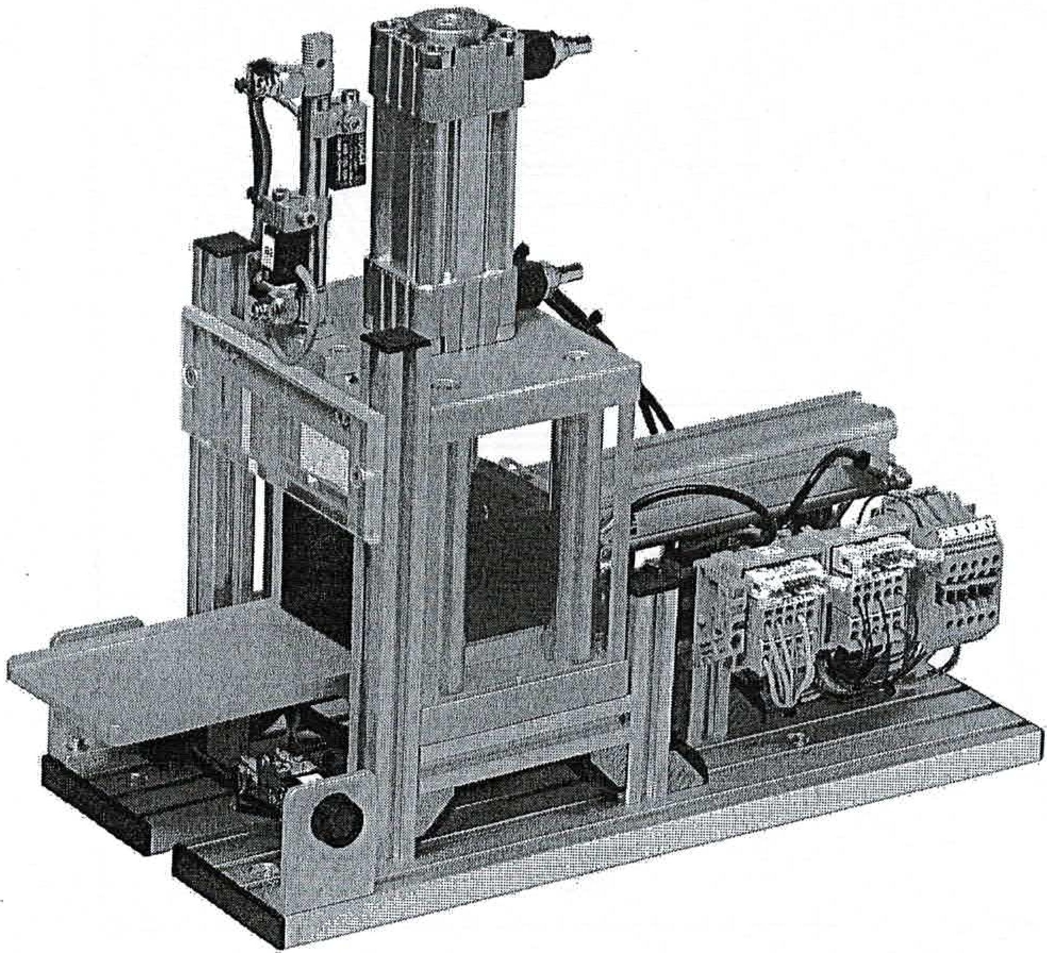

by Dr.-Ing. Paul Christiani GmbH & Co. KG

5

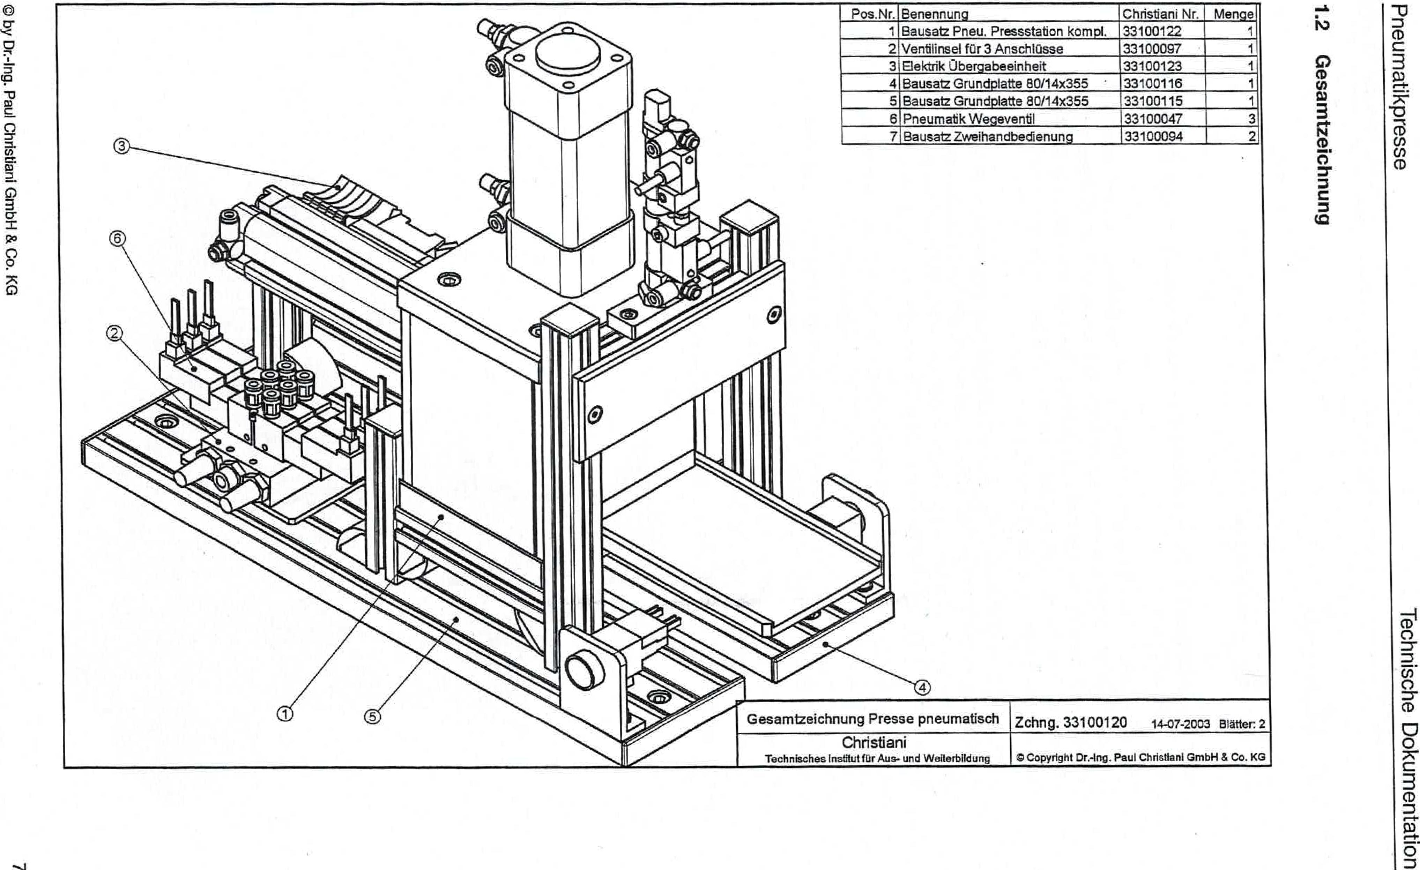

0 by Dr.-Ing. Paul Christiani GmbH*&*Co. KG

**6unuqopnwese9**

IV

assaideewnaud

uopluawnloo eilospLpoi

|  |  |  |  |
| --- | --- | --- | --- |
| Item No. | designation | Christiani No. | Crowd |
| 1 | Construction salt pneumatic press station complete. | 33100122 | 1 |
| 2 | Valve island for 3 connections | 33100097 | 1 |
| 3 | Electrical transfer unit | 33100123 |  |
| 4 | Base plate kit 80114x355 | 33100116 | 1 |
| 5 | Base plate kit 80/14x355 | 33100115 | 1 |
| 6 | Pneumatic directional valve | 33100047 | 3 |
| 7 | Two-hand operation kit | 33100094 |  |

General drawing of pneumatic press
  
Christiani

Technical Institute for Education and Training

Drawing 33100120 14-07-2003 Blatter: 2

13 Copyright Paul Christlanl GmbH & Co. KG